How to setup the router for Static IP internet connection mode
Product line: Wireless Model number:FH330
There are three internet connection modes for the router. This article will guide you how to setup the router for Static IPmode and the steps as below.
Note: If you have no idea about what is the internet connection type and the accounts please call your ISP for them.
Part 1: Connect the devices
Part 2: Configure your computer
Part 3: Setup the router
Part 4: Check whether you can access internet
Connect the modem with the WAN port of the router, and then connect your computer with one of the LAN ports by a cable.
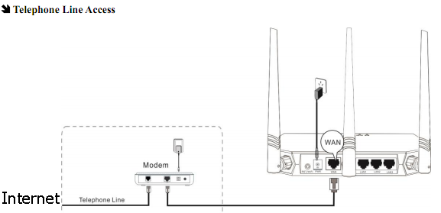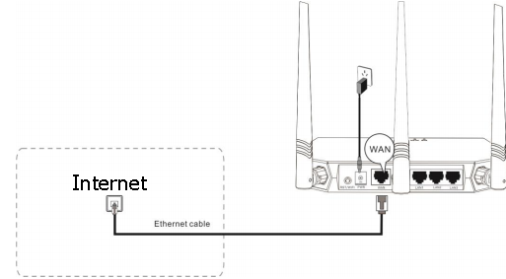
Note: after connection the SYS light should be blinking, the WLAN light should be on or blinking, the WAN light should be on or blinking.

1 Click on Network Connection Icon on the system bar, then click on Open Network and Sharing Center.
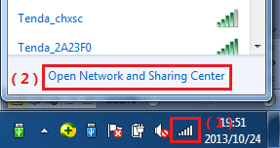
2 Click on Change adapter settings.
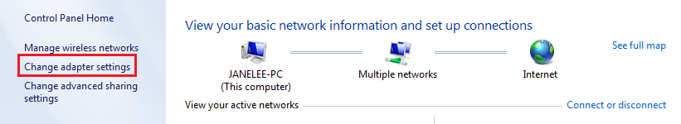
3 Right click on Local Area Connection, then choose thePropertiesoption.
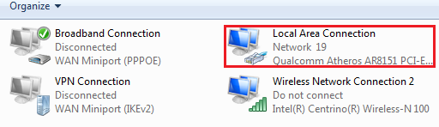
4 Double click on Internet Protocol Version 4(TCP/IPv4)
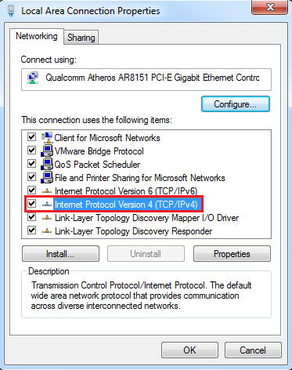
5 Choose Obtain an IP address automatically andObtainDNS server address automatically and then click OK.
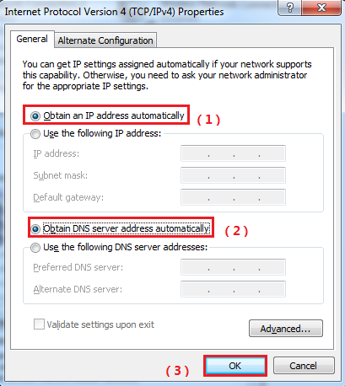
6 Also click onOK on the first Local Connection Properties window.
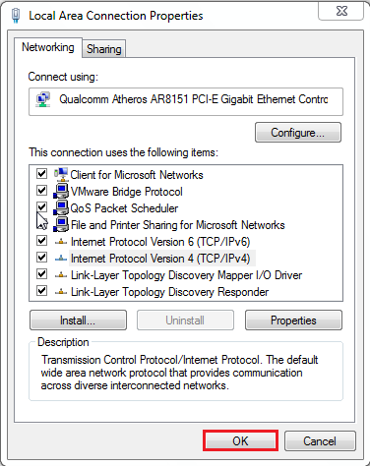
1Open a browser then type192.168.0.1 in the Address bar, click on Enter.
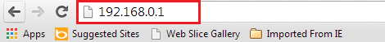
2 Type the Username and Password（default: admin）in the bars then click on the Login button to login the setting page.
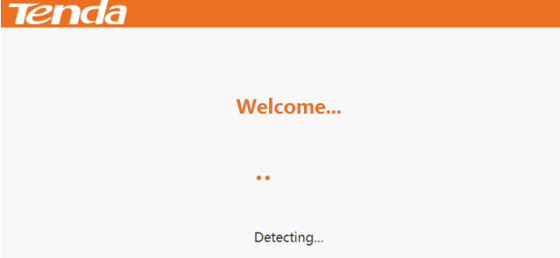
3 If the Setup Wizard detects that your Internet connection is Static IP,you will see the figure below:
Click Next to go forward.
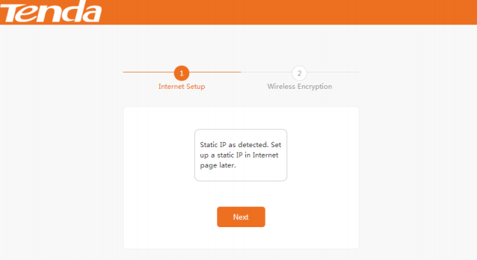
4 You can secure your wireless network on this page. The default Wi-Fi Name can be seen here on the Router’s label.
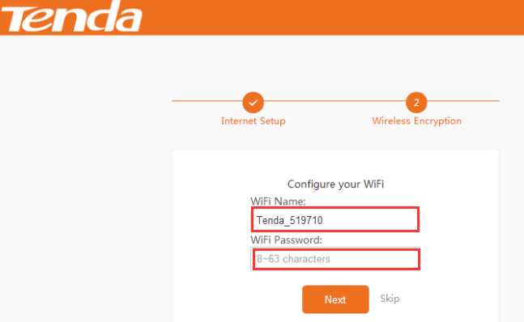
1.Change the WiFi Name to your custom name for easy recognition.
2.Customize a WiFi password in the WiFi Password field,and click Next.
The page below will appear and hold for three seconds, and you will be directed to the Static IP setup page.
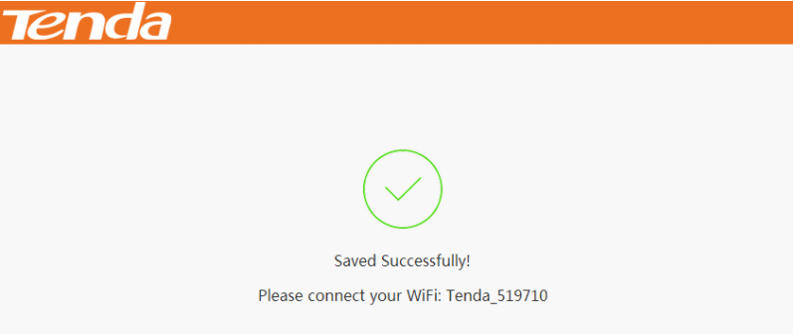

- Input the Static IP info your ISP gave you, and click OK to save and active your settings.
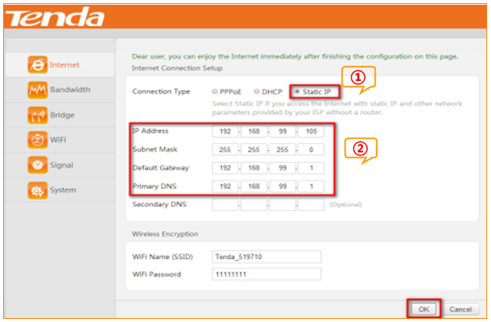
1 Check the Connection Status, if it shows Internet Access, it indicates that you can access the Internet.
